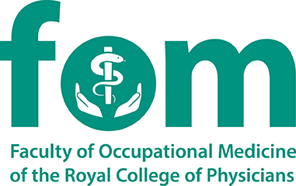
APPLICATION FORM FOR KEY APPOINTMENTS
AND MEMBERSHIP OF COMMITTEES,
SUBCOMMITTEES AND WORKING GROUPS

Trainee Representative
This form should be completed electronically and emailed, with an up-to-date CV, to training@FOM.ac.uk by 5:00 pm on Monday, 8 May 2023

Full Name
Business Address
Home Address
Email Address
Telephone Number

Professional Qualifications (with dates)
Date of Full Registration with the GMC

Current Training Appointment
Current Stage of Training
Anticipated CCT Date

Previous roles within the Faculty of Occupational Medicine (with dates)

Please explain, in no more than 250 words, your suitability for the post:

I confirm that both my employer and my Educational Supervisor have given permission for me to submit this application.

I confirm that the above information is accurate and understand that the information given on this form may be circulated to a Faculty of Occupational Medicine appointment panel.

I confirm I will include an up to date CV with this application form

Signature  (Digital signature is acceptable) |  | Date

